CUSTOMER

* Customer can view the site after going to homepage even if they are not logged in:

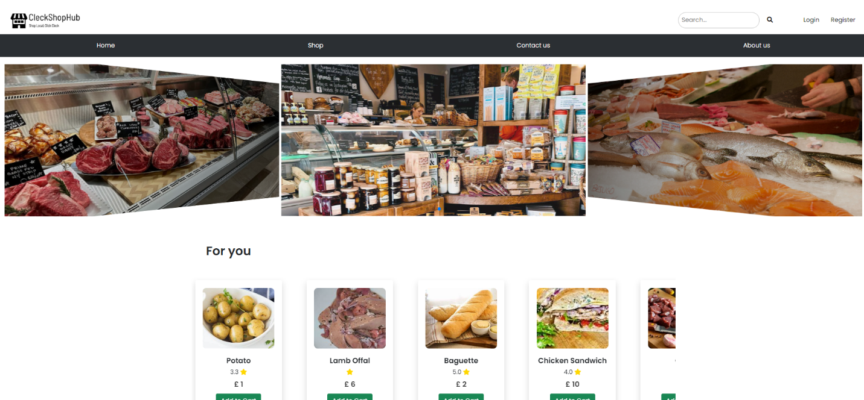

* Customer can Click on either Login or Register in Header on top right
* If you already have an account then you can directly login into your account by clicking on Login from the header, then this page is displayed:

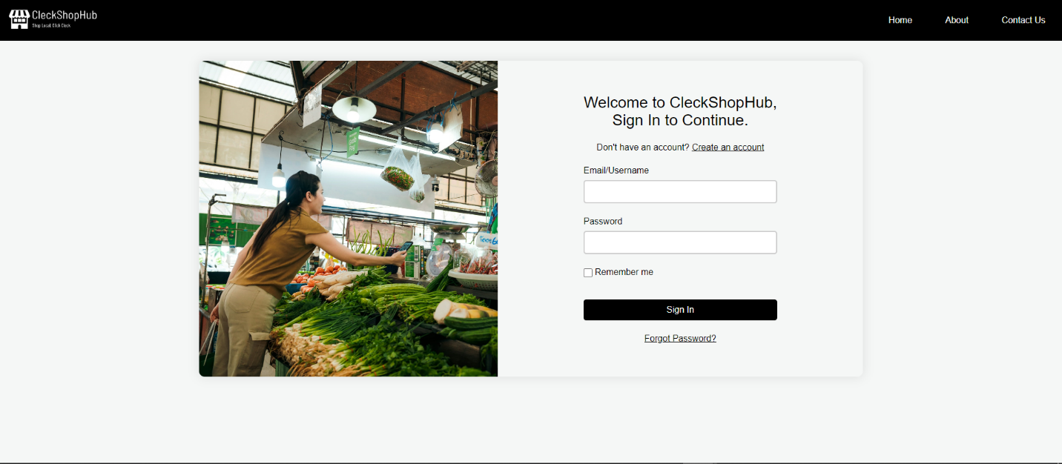

* If the user clicks register then this register page is displayed:

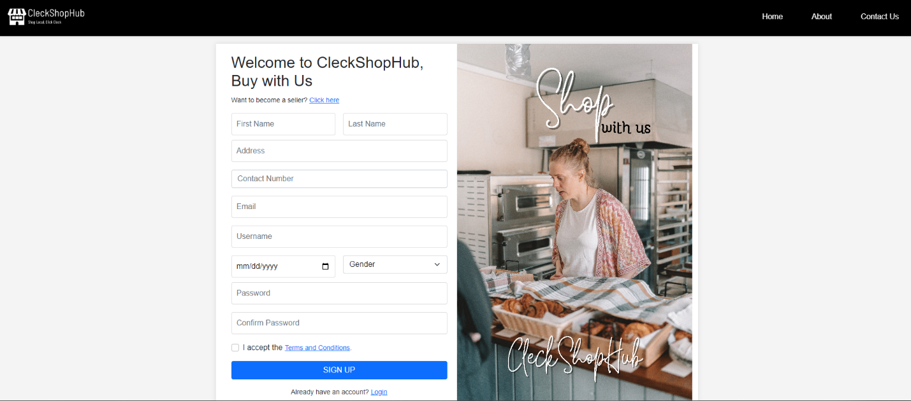

* You can create a new account as customer by filling in the register form.

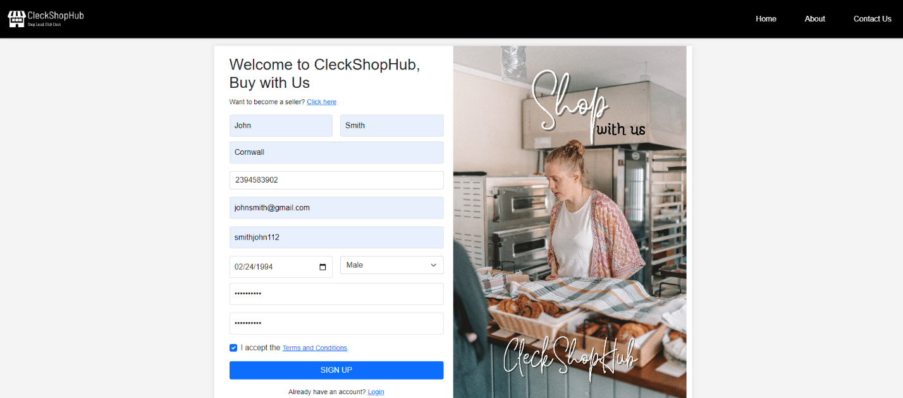

* After filling in the input fields with valid information you’ll receive OTP verification code in user’s entered email address.

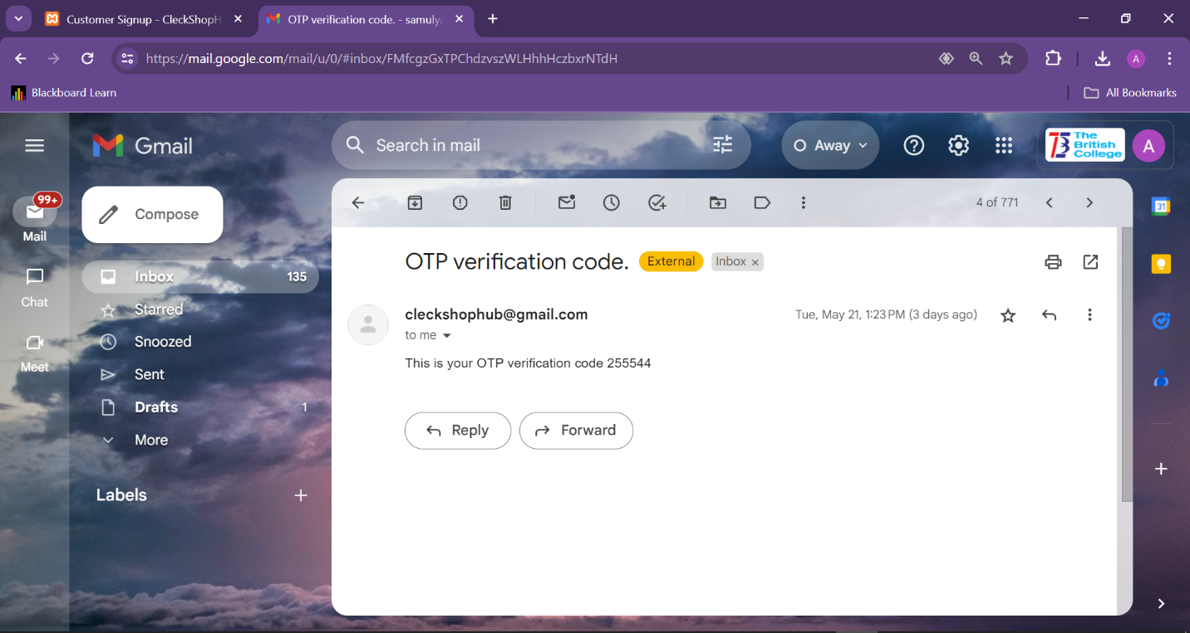

* After being verified you’ll be able to login as customer in this website and your homepage will look something like this.

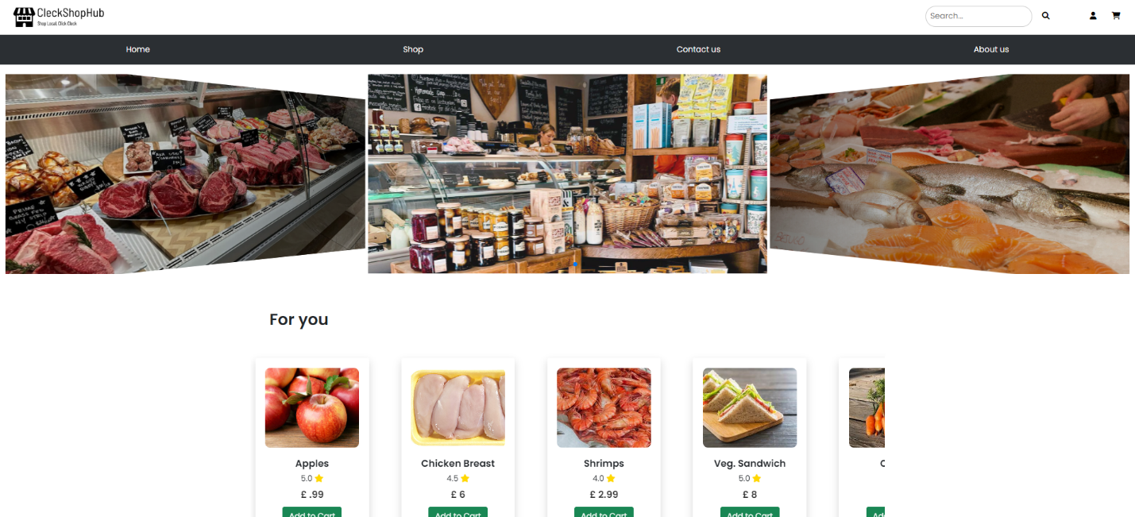

* User can also view their about us page which looks like this:

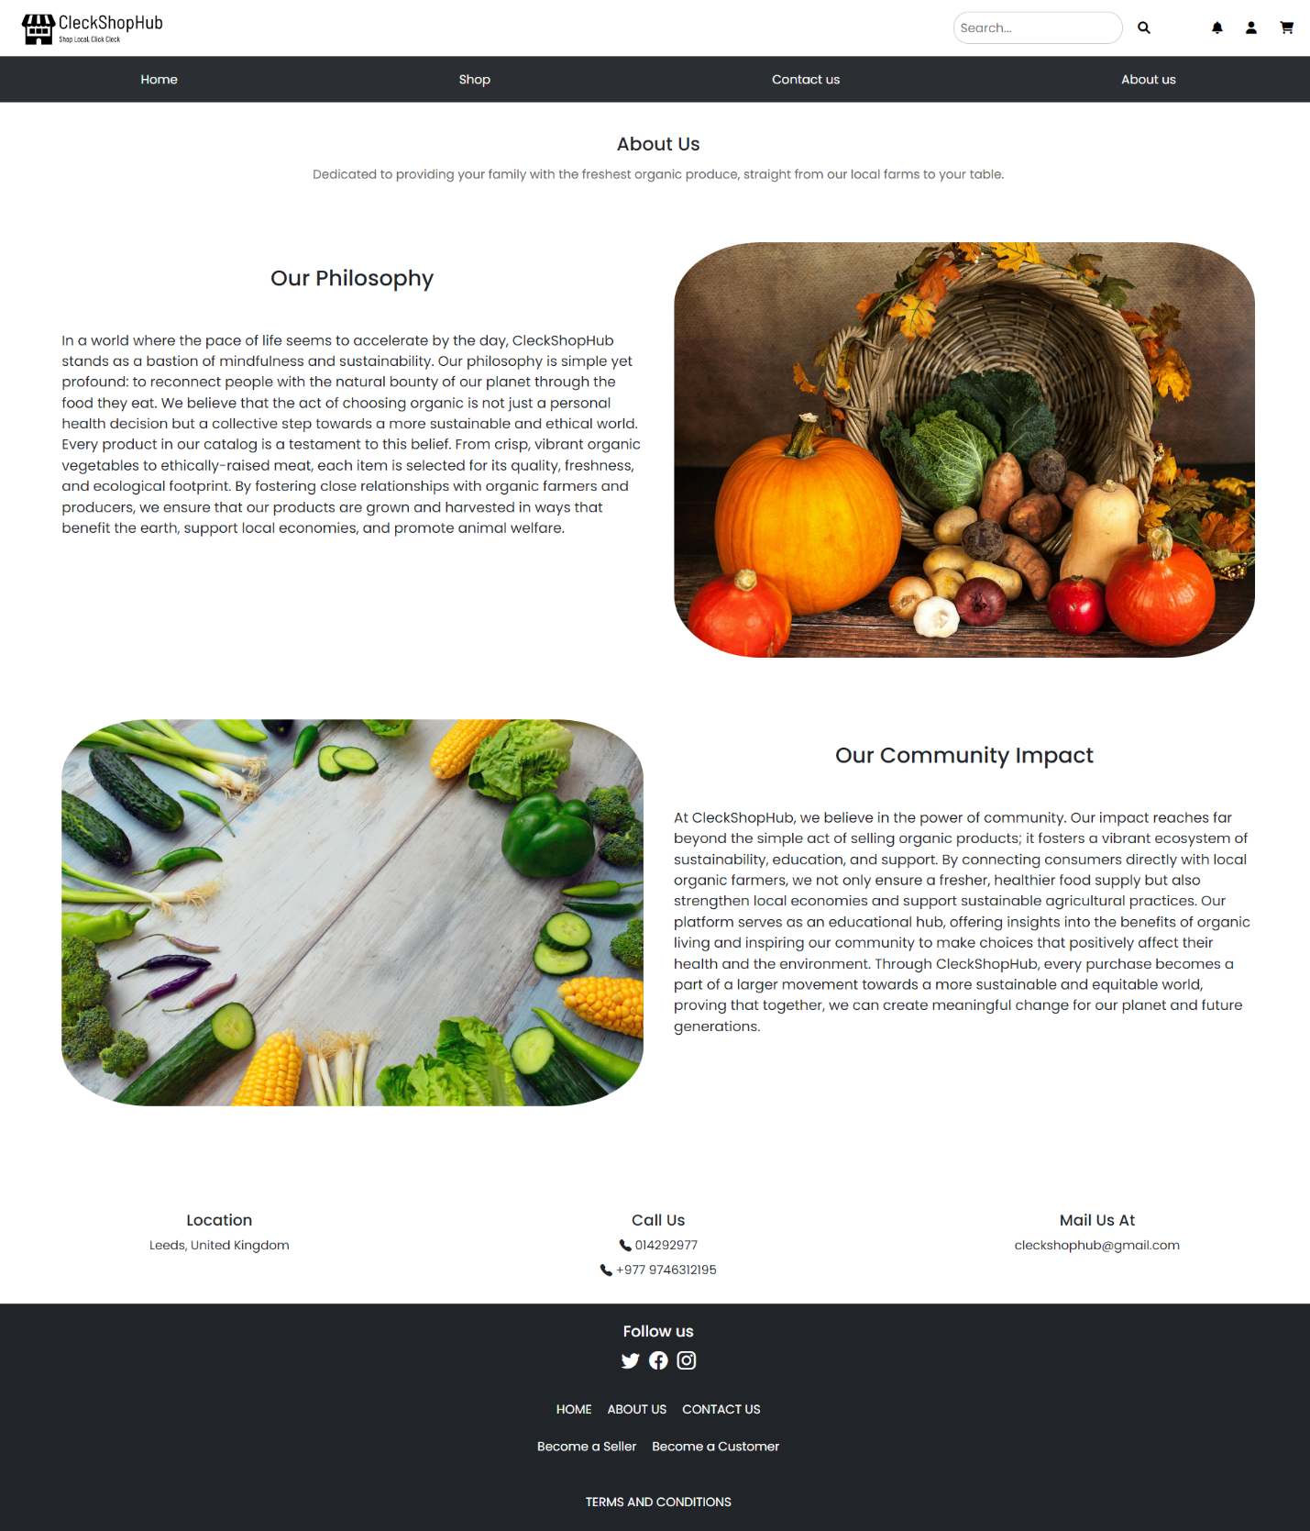

* If you want to know about the traders in CleckShopHub then you can click on Shop from the navigation bar and select the shop page you want to visit.

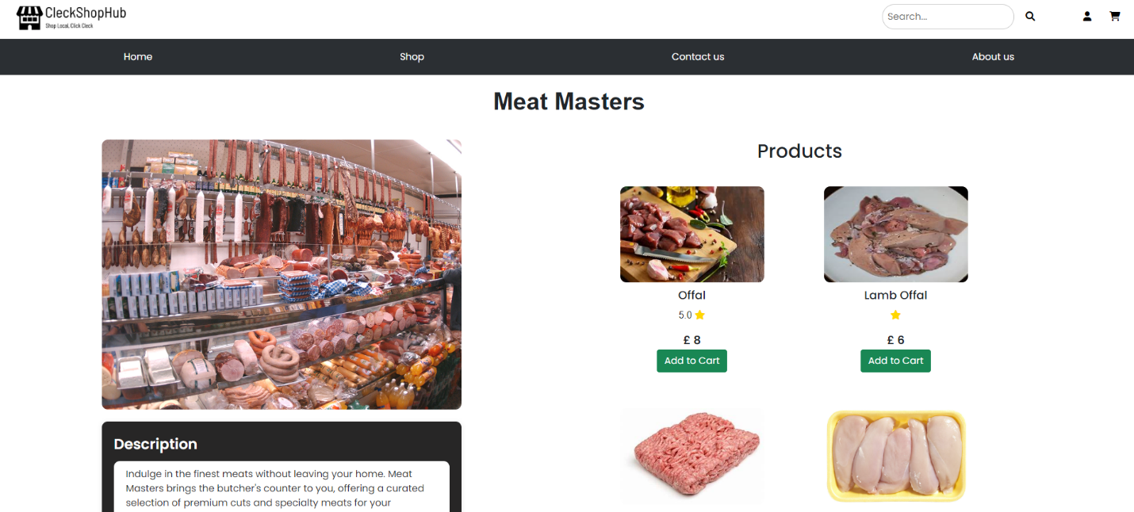

* User can contact CleckShopHub for any inquiries or feedback from Contact Us page

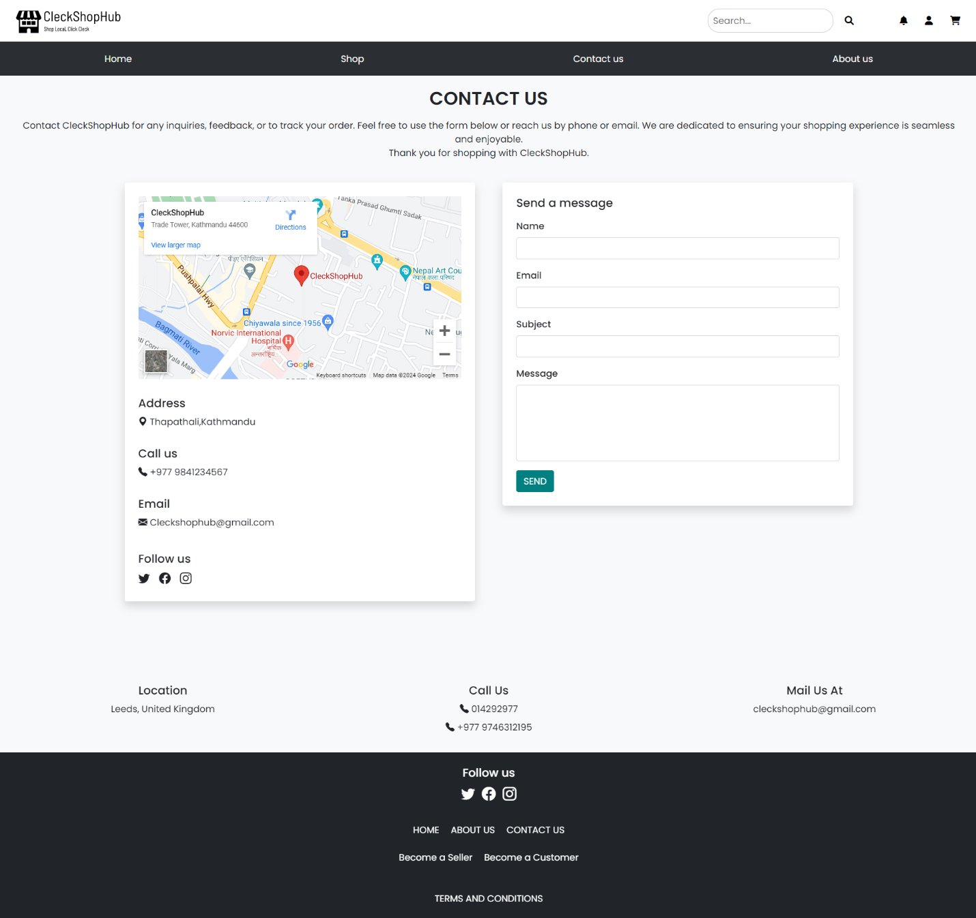

* User can hover over Shop in navigation bar to know about the traders in the website as shown below in the picture

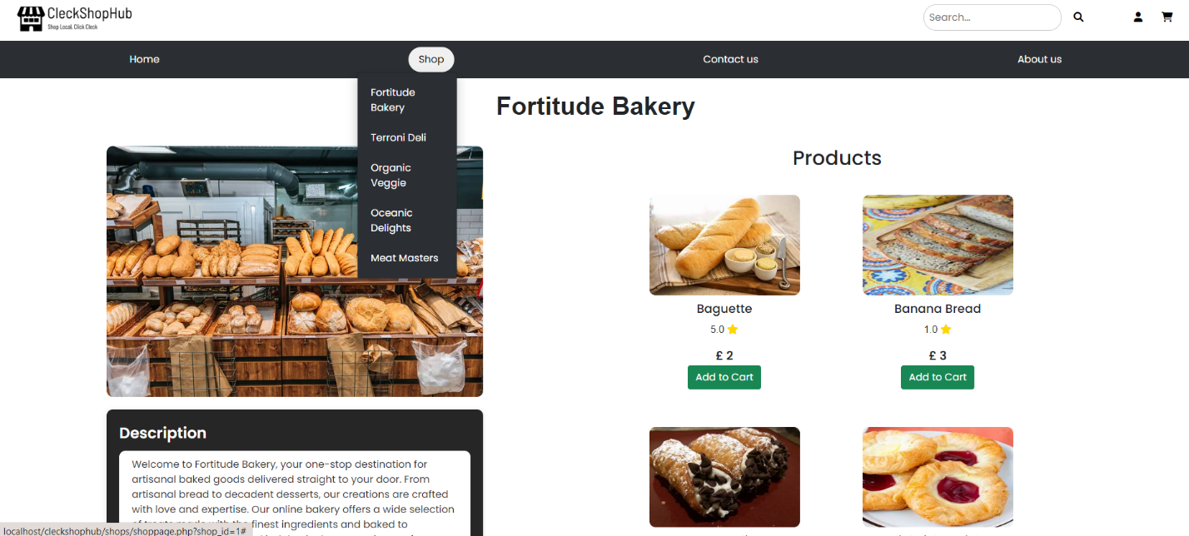

* You can also search products according to category.

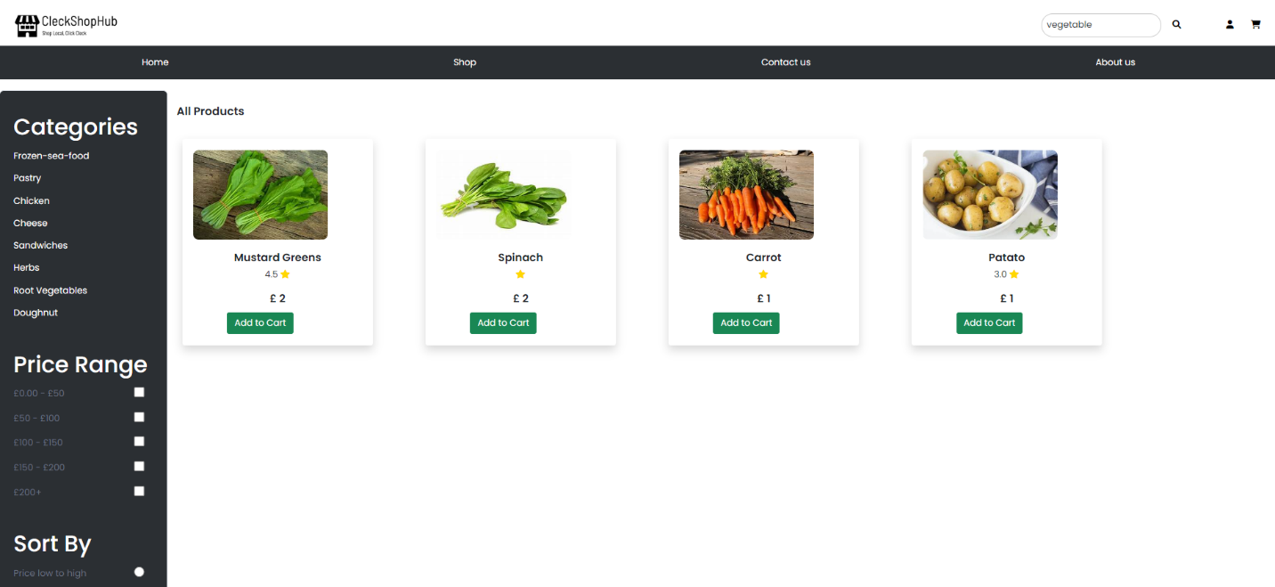

* If you want to search for a specific product then you can type in the search field, select a category and then press search.

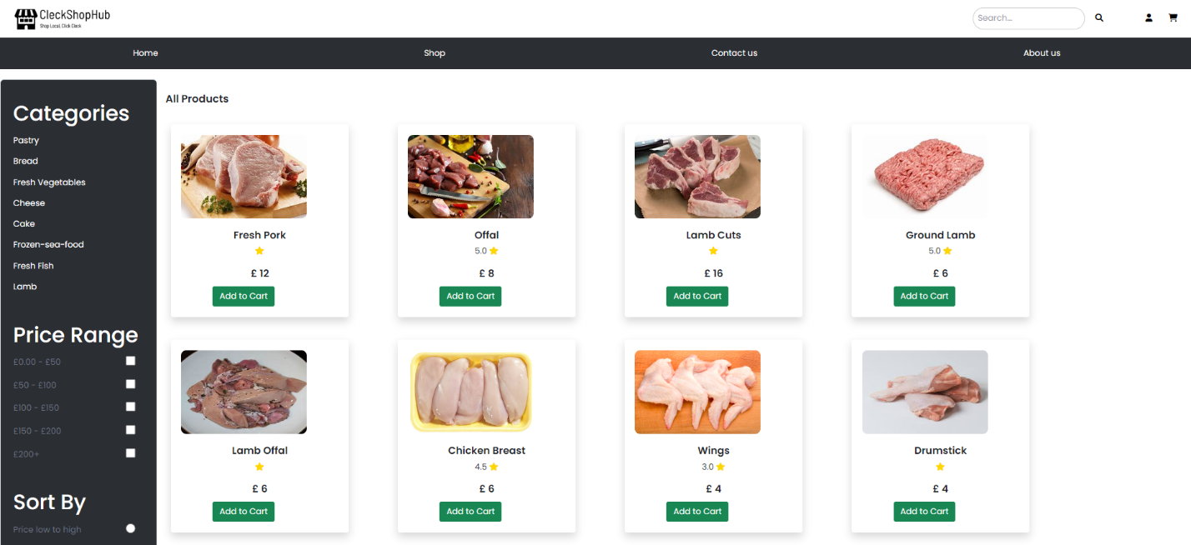

* You can view the product details by clicking on specific product.

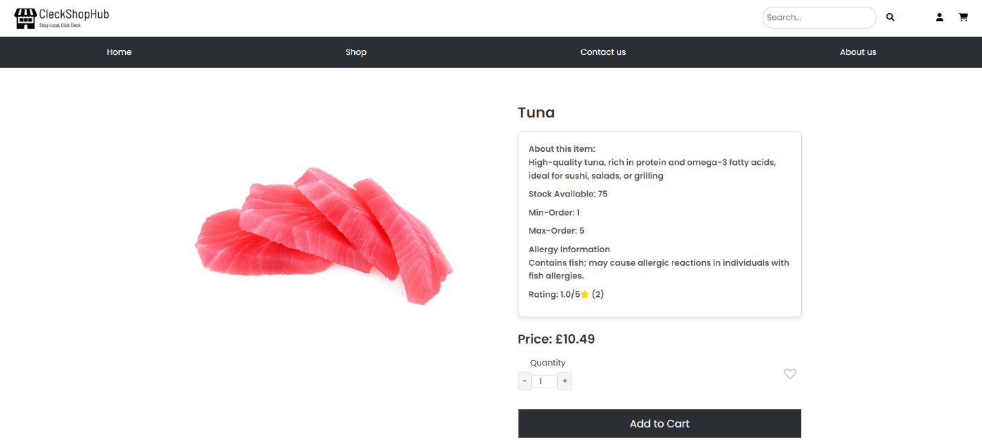

* You can also add reviews to the products by clicking on the blue button labelled “Write a review”

and give ratings on a product on the basis of stars.

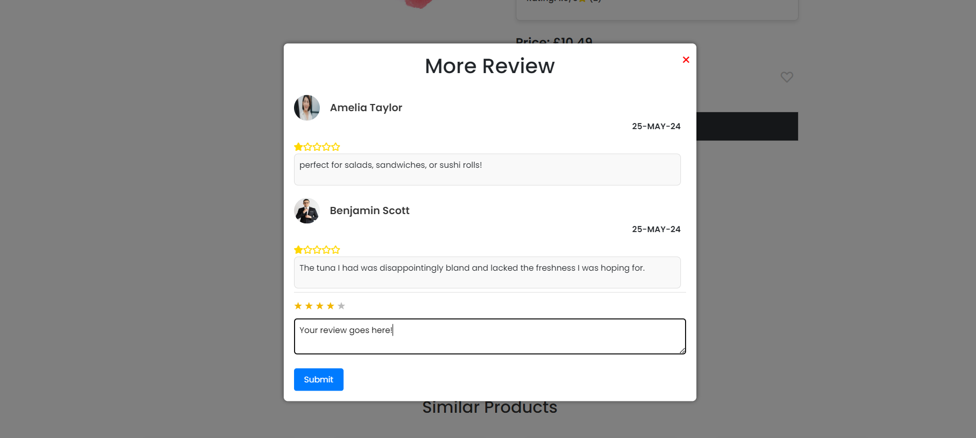

* If you want to add products to your favorite then you can click on the heart shaped button

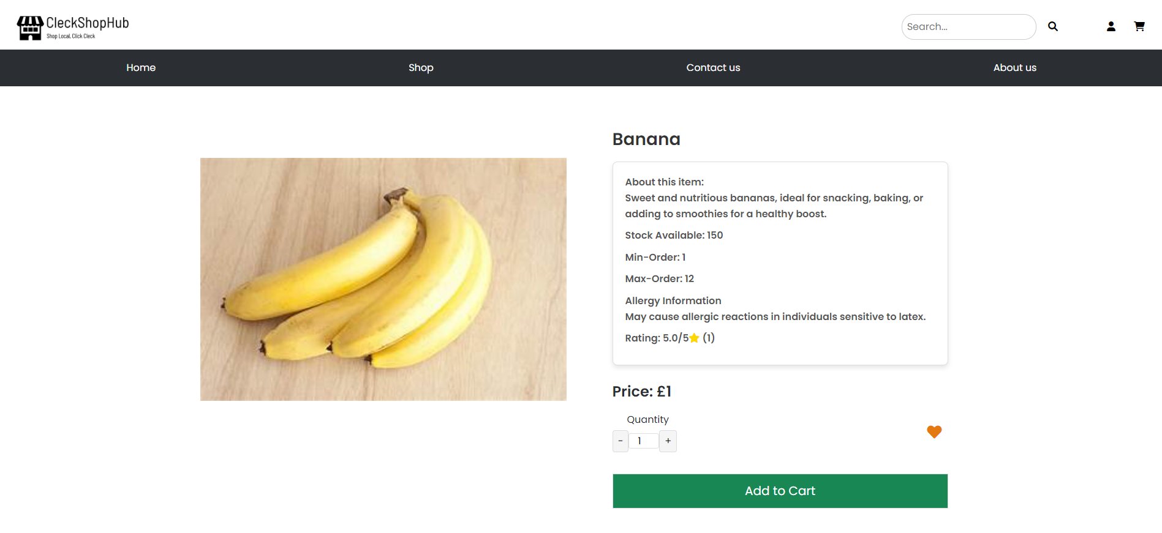

* You can view your Favorite products by clicking on the profile icon in the navigation bar and then selecting Favorites option, which will redirect you to Favorites page. Your Favorites page will look like this.

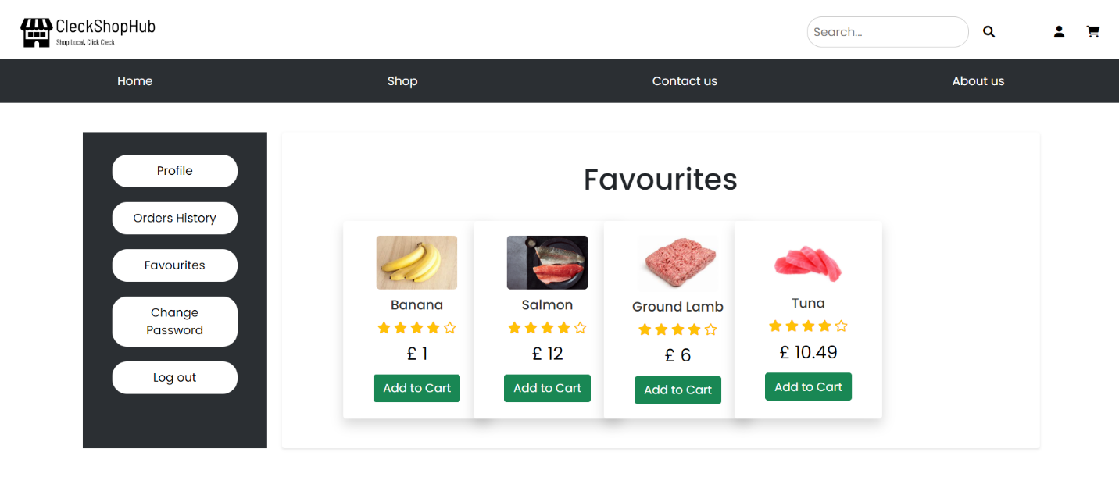

* If you want to add items to the cart then click on ‘ADD TO CART’ button.



* When you add items to the cart, the items will appear in the Cart and you can further view the cart after clicking on the cart icon on navigation bar.

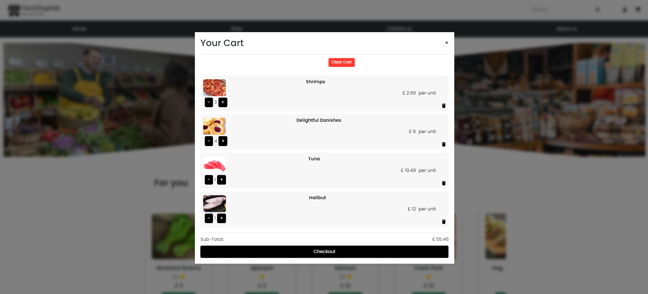

* You’ll be notified about your order placed through email.

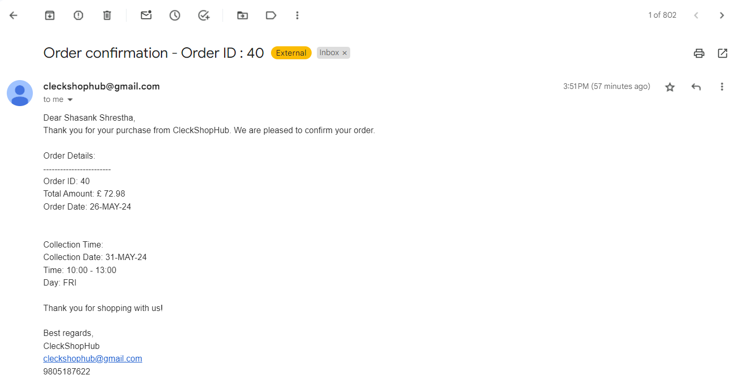

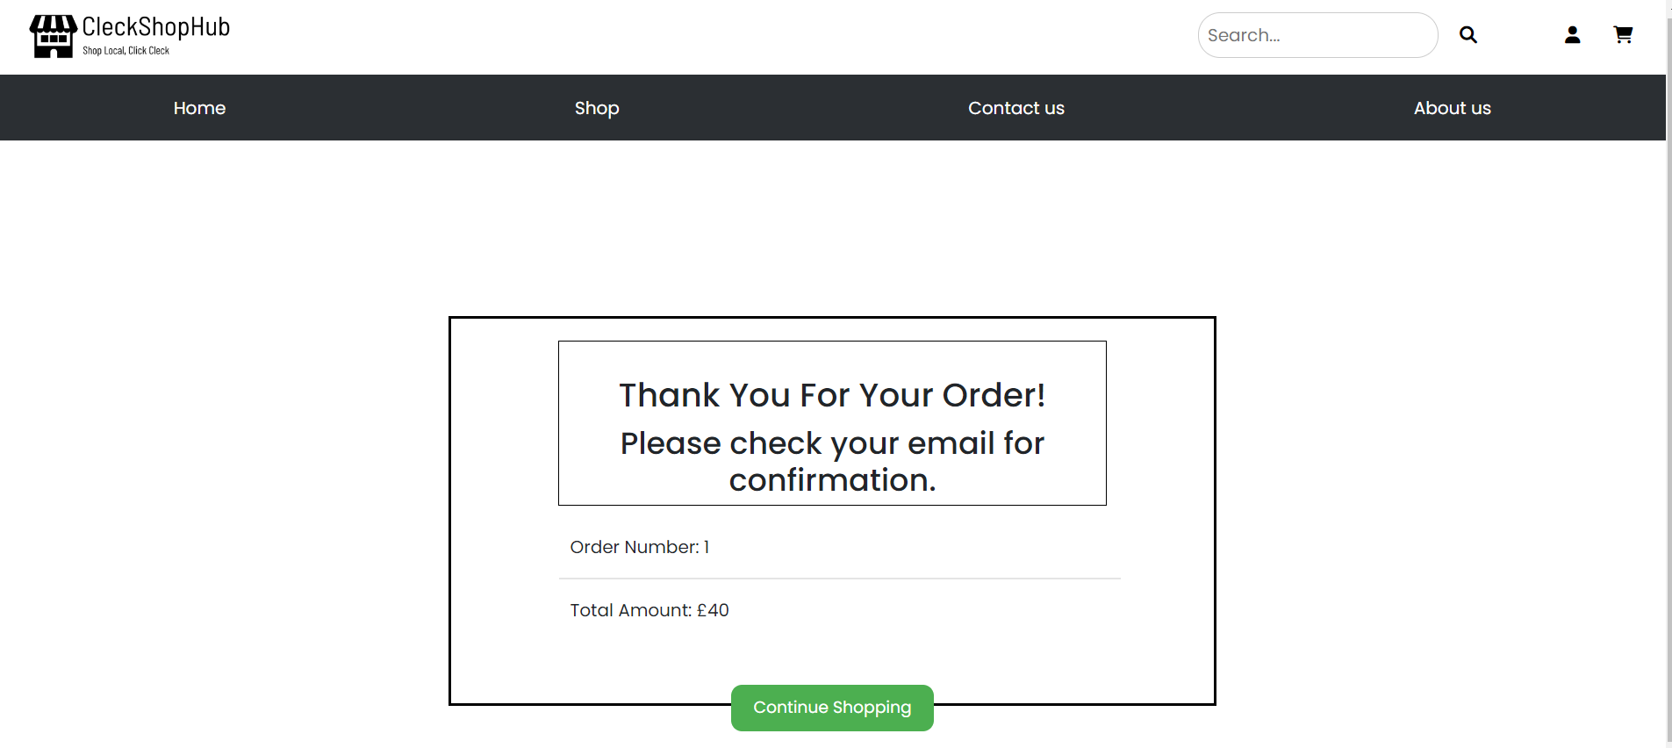

* If you click on the profile icon in navigation bar then you can see two options. If you click on the profile option then it will redirect you to your profile page.

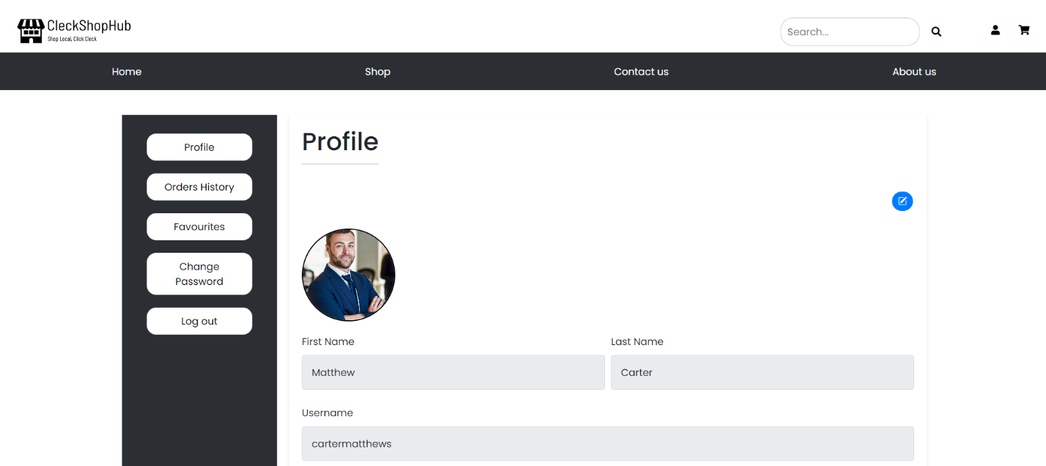

* When you’re in your Profile page, you can edit your personal info like contact number, address and name.

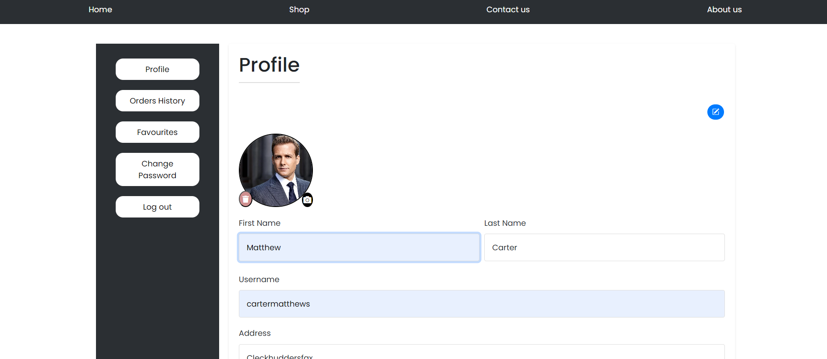

* You can also change your profile picture after clicking on the camera icon and you will be asked to pick an image with Jpeg/jpg format.

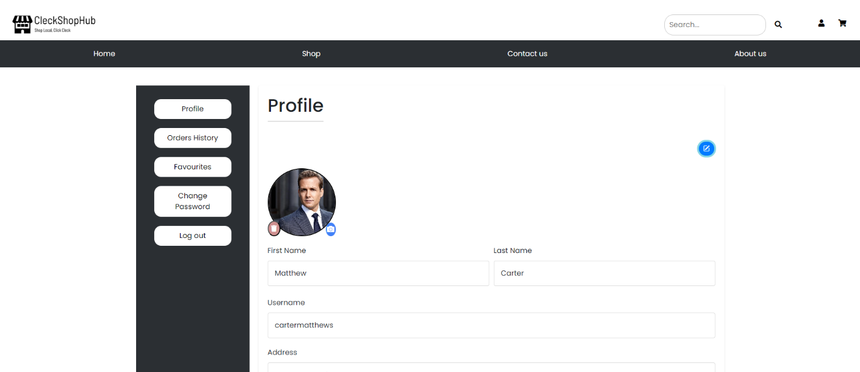

* You can also view order histories after clicking the Order History tab

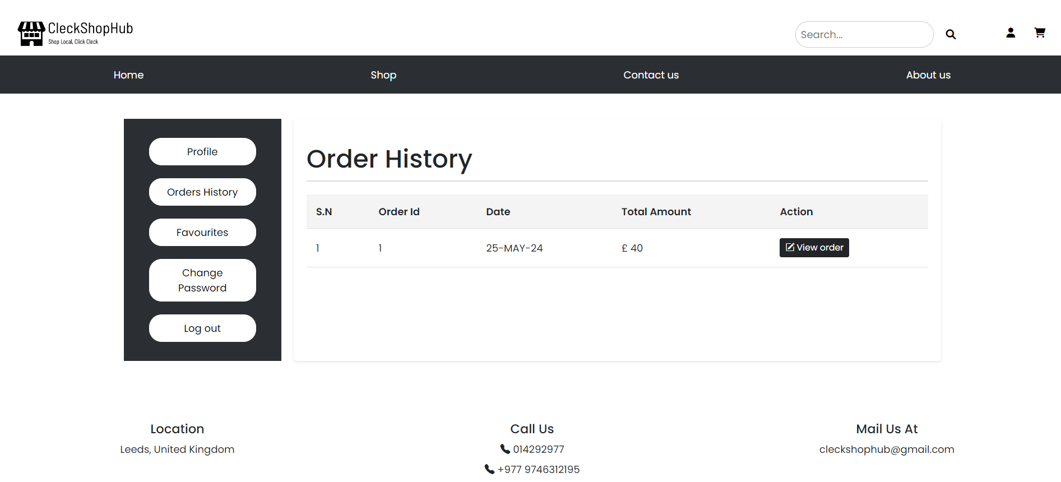

* 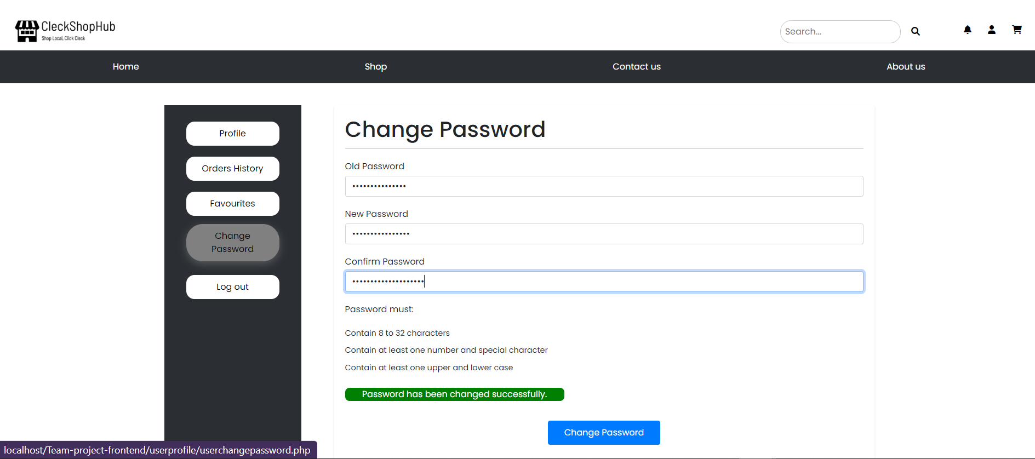If you want to change or update your password, you can click on Change Password then you will be prompted to enter old password along with the new password, and after successfully updating password it will display a message in green text.
* If you want to logout of your account then you can click on your profile and then click on logout, which will redirect to website homepage.



* 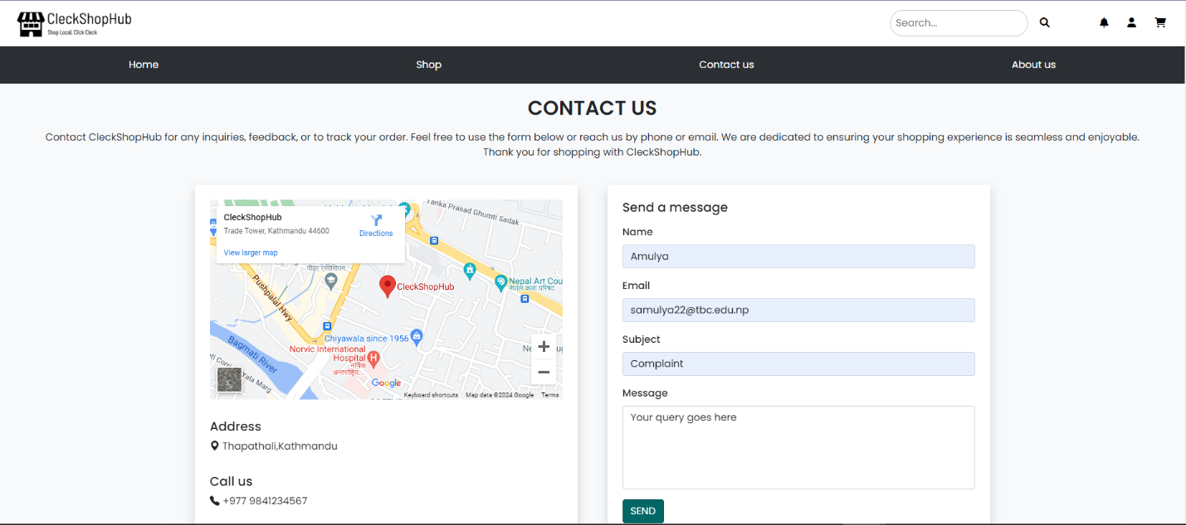You can also provide feedback after clicking on Contact Us from navigation bar and entering details like email address, name, subject and your message.